**CAPITAL AREA ARCHIVISTS OF NEW YORK**

**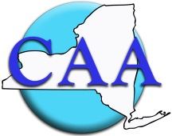**

**C:\Program Files (x86)\Microsoft Office\MEDIA\OFFICE11\Lines\BD21527_.gif**

Tour of the Rensselaer County Historical Society

Annual Meeting for Election of Officers to Follow

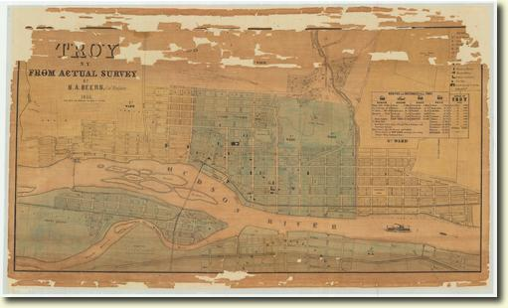

Rensselaer County Historical Society

57 Second Street

Troy, NY 12180

(518) 272-7232

Wednesday, June 25, 2014

5:30 – 7:30 PM