### The Capital Region Archives Dinner Committee, a program of Capital Area Archivists of New York (CAANY), is proud to present the Twenty-Fourth Annual Capital Region Archives Dinner at Key Hall at Proctors Theater in downtown Schenectady NY.

**The Twenty-Fourth Annual**

**Capital Region Archives Dinner**

Dr. Laura Wittern-Keller is the author of *Freedom of the Screen: Legal Challenges to State Film Censorship* and co-author of *The Miracle Case: Film Censorship and the Supreme Court*. She will speak on New York’s extraordinary collection of movie censorship records and the archivist who not only became a head censor but who also preserved the records for our use today.

*The Archives Dinner Committee is also pleased to recognize individuals and organizations who or which have made significant contributions to the preservation and enhancement of local archives as part of our annual celebration:*

*Jack McEneny Award for Archival Advocacy*

*Laura Lee, Association of Public Historians of New York State*

*Sister Elaine Wheeler Award for Distinguished Service in Archives*

*Kelly Farquhar, Historian and Records Management Officer, Montgomery County*

*Deborah Escobar Historical Records Education in the Schools Award*

*Tasha Anderson, Mohonasen Central School District*

*Previous award winners include Michelle Furlong, Brian Stratton, Theresa Fahy, Tony Opalka and James Davies, Jessica Maul, Kevin Franklin, Kathleen Roe, Donna Conlin and Diane Hutchinson, Ray LaFever, John McDonald, and the Rensselaer County Historical Society.*

**PROCTORS THEATER** on State Street in downtown Schenectady is home to several facilities under one roof, including **KEY HALL**, a restored former bank, complete with walk-in vault and high vaulted ceilings. Now used for events, Key Hall can be reached by either the State Street entrance to Proctors or the rear entrance near the parking garage. Walk inside the historic arcade to the Key Hall entrance opposite the Proctors Box Office.

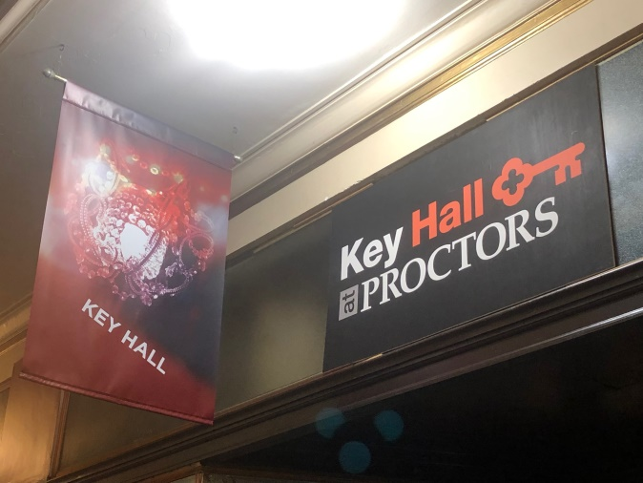

*FREE PARKING after 5 pm is available on all the streets surrounding Proctors, including the downtown municipal parking garage at 220 Broadway.*

**



Capital Area Archivists of New York is the not-for-profit 501(c)(3) organization serving our region's archival community. To learn more, visit www.capitalarchivist.org

**Become a CAANY member now by paying our modest $5 annual dues with your reservation!**

You Are Cordially Invited to Join Us on

**THURSDAY**

**OCTOBER 10, 2019**

**Cash Bar 5:30 PM Dinner at 6:30 PM**

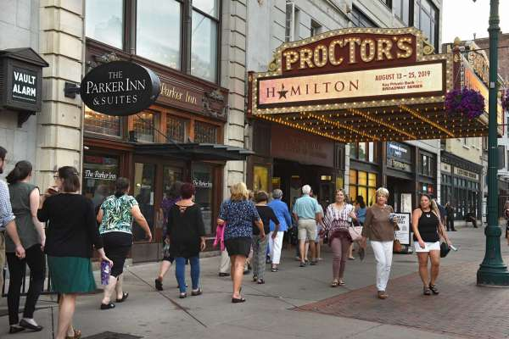

Key Hall at Proctors Theater

432 State St., Schenectady

|  |
| --- |
| **T h e C a p i t a l R e g i o n**  **A r c h I v e s D I n n e r C o m m I t t e e** |

* Brian Keough, Head, Special Collections & Archives, University at Albany, *Co-Chair*
* Bonita L. Weddle, Associate Archivist, NYS Archives, *Co-Chair*
* Emily S. Allen, Archivist, NYS Archives
* Craig A. Carlson, Deputy Albany Co. Clerk
* Thomas Clingan, retired Albany Co. Clerk
* Bruce A. Hidley, Albany Co. Clerk & RMO
* Chris Hunter, Curator, miSci – the Museum of Innovation and Science, Schenectady
* Laura Lee, Registered Historian, Assn of Public Historians of NY State
* Michael Maloney, Archivist, New York State Archives
* Denis P. Meadows, Director of Government Records Services, NYS Archives
* Kathleen A. Newkirk, retired Bethlehem Town Clerk and RMO
* Rebecca Shevy, Archivist, Albany County Hall of Records

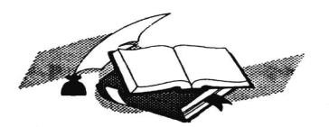

*We come together one evening each year, in celebration of archives;*

*to honor and appreciate those whose work draws its life*

*from our documentary heritage.*

For twenty-four years, the Capital Region Archives Dinner has celebrated the archival heritage of Albany, Columbia, Fulton, Greene, Montgomery, Rensselaer, Saratoga, Schenectady, Schoharie, Warren, and Washington counties in New York State.

*We gratefully acknowledge the financial support of the New York State Archives Partnership Trust and the University at Albany Special Collections for this event.*

**The**

**Twenty-FOURTH**

**Annual**

**Capital Region Archives Dinner**

***Thursday, October 10, 2019***

Cash Bar & Hors d’oeuvres – 5:30 pm

Dinner and Program – 6:30 pm

Dr. Laura Wittern-Keller

Department of History, University at Albany

**The Archivist as Censor/The Censor as Archivist: Hugh Flick and the Motion Picture Division**

*as well as*

Awards, Recognitions, and Appreciations

Please send all reservations for the Archives Dinner at Key Hall by Tuesday, October 1, 2019, to the address below.

*Please reserve dinners at $40.00 each:* (Indicate number for each choice of entrée).

Braised boneless short rib with cauliflower potato puree and glazed carrots

Honey soy glazed salmon with mango chutney, basmati rice pilaf, and stir fried carrots and peppers

Crispy eggplant with fresh tomatoes, garlic, basil, mozzarella, ricotta, pecorino, capellini nest, and marinara sauce

*Join CAA right now! Check here*  *then add $5 to your check to pay your 2019-20 annual dues.*

**Please make your check payable to "CAA - Archives Dinner”**

###### Name(s)

Address

Telephone

E-mail _

Affiliation (optional)

*Please RSVP by October 1, 2019.*

**Seating is limited to 125 people.**

**Mail all reservations to Bonita Weddle, New York State Archives, 9B31 CEC, Albany, NY 12230. FOR INFORMATION: (518) 473-4258 or** [**bonita.weddle@nysed.gov**](mailto:bonita.weddle@nysed.gov)